EXP NO : 5 Implement K-Means Clustering

AIM : To implement the K-Means Clustering algorithm using Python to group students based on their hours studied and marks, divide them into three clusters, and visualize the clusters along with their centroids using Matplotlib.

ALGORITHM :
- Start the program.
- Import the Pandas library, Matplotlib, and the KMeans algorithm from Scikit-learn.
- Load the dataset from the file data.csv.
- Select Hours_Studied and Marks as the input features.
- Create a K-Means clustering model with three clusters using KMeans(n_clusters=3, random_state=42).
- Fit the model to the selected data using kmeans.fit(X).
- Obtain the cluster labels using kmeans.labels_.
- Add a new column named Cluster to the dataset to store the cluster labels.
- Display the clustered dataset.
- Plot the data points using a scatter plot, with different colors representing the clusters.
- Plot the cluster centroids using the marker X.
- Add axis labels, a title, and a legend to the graph.
- Display the graph using plt.show().
- Stop the program.
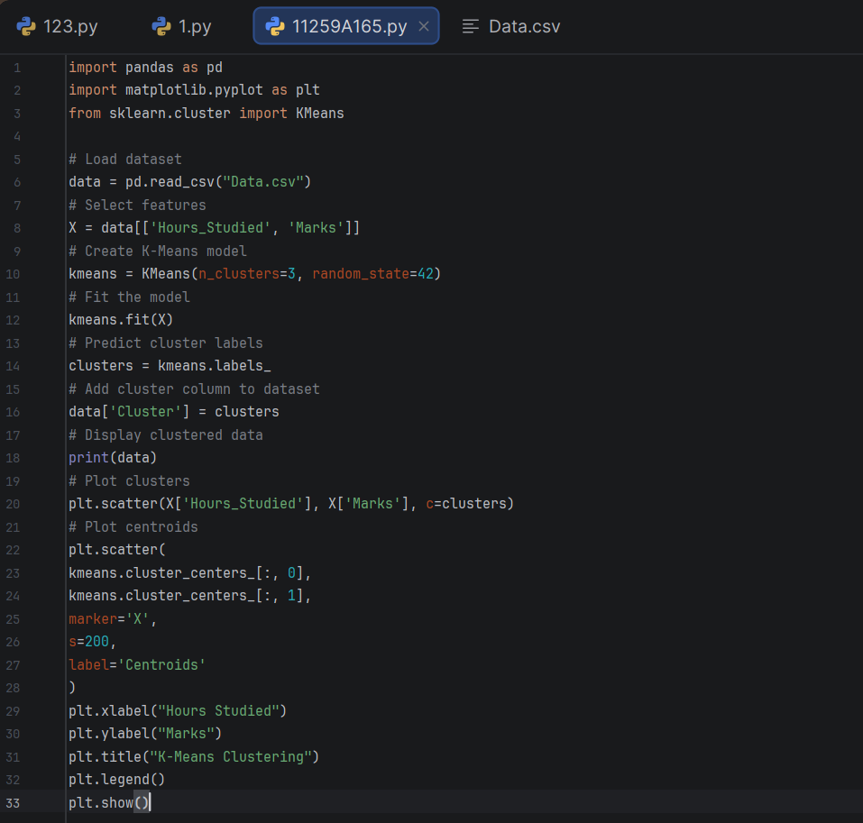
PROGRAM :

OUTPUT :
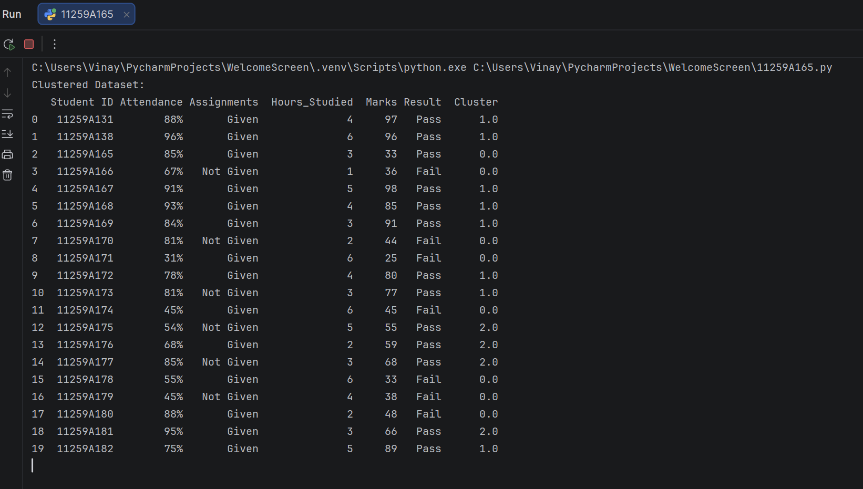

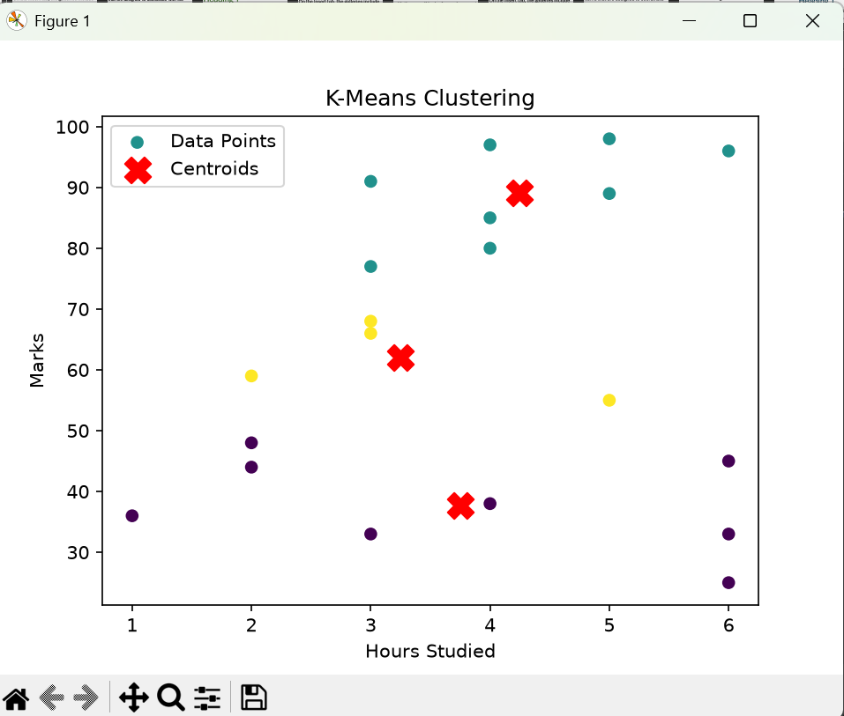

RESULT : Thus, the K-Means Clustering algorithm was implemented successfully to group students based on their hours studied and marks into three clusters. The clustered dataset was displayed, and a scatter plot showing the clusters and their centroids was generated.

